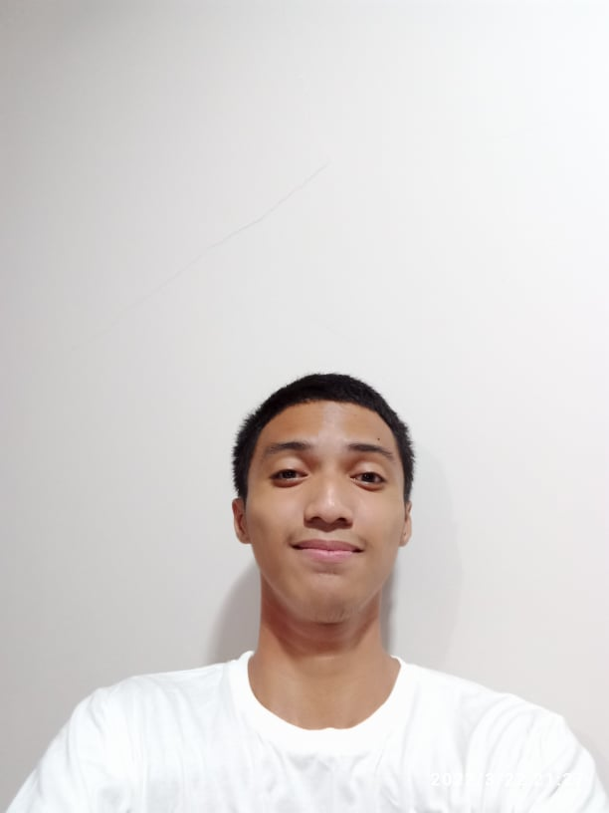**Name:** Ralph Jan P. Gallegos **Address:** Honesty St. Ficoville, Iponan, CdOC. **Mobile no.** 09056548089 **Email Address:** [ralp.pelino11@gmail.com](mailto:ralp.pelino11@gmail.com)

**PERSONAL INFORMATION: Full name:** Ralph Jan P. Gallegos **Age:** 21 years old **Gender:** Male **Date of Birth:** November 08, 2001 **Birth Place:** Carmen, Cagayan de Oro City **Status:** Single **Citizenship:** Filipino **Religion:** Roman Catholic

**CAREER OBJECTIVE:** To make use of my interpersonal skills to achieve goals of a company that focuses on customer satisfaction and customer experience. Above average ability to multitask and prioritize tasks during shift.

**EDUCATIONAL BACKGROUND:** Bachelor of Science in Information Technology

PHINMA Cagayan de Oro College

**PERSONAL SKILLS:**

* React.js framework experience
* Computer Skills
* Node.js backend development
* Management Skills
* Time Management
* Transferable Skills

**EMPLOYMENT HISTORY:** 3 years of experience in being a software developer in the PHINMA COC